Week 5: VPC Creation and Ec2 Instance Connection

🔹 Step 1: Create the VPC
- Go to AWS Management Console → VPC
- Click Create VPC
- Choose VPC only
- Enter:
  - Name: Custom-VPC
  - IPv4 CIDR block: e.g. 10.0.0.0/16
- Click Create VPC

🔹 Step 2: Create Subnets (Public & Private)
Create subnets in same Availability Zones for high availability.

Example:
- Public Subnet: 10.0.1.0/24 (AZ-A)
- Private Subnet: 10.0.2.0/24 (AZ-A)
Steps:
- Go to Subnets → Create subnet
- Select your VPC
- Choose AZ
- Enter CIDR
- Create subnet
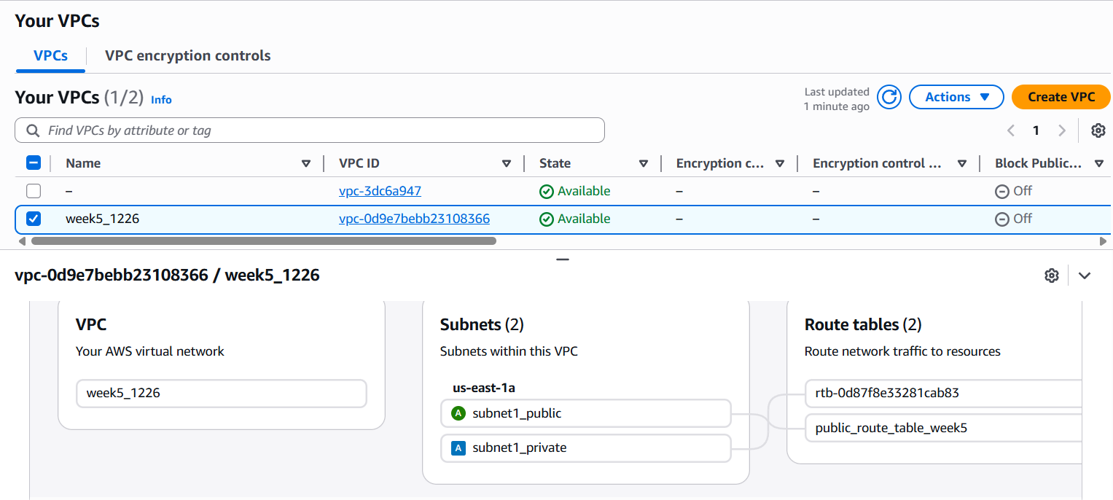

🔹 Step 3: Create an Internet Gateway (IGW)
- Go to Internet Gateways
- Click Create internet gateway
- Name it Custom-IGW
- Attach it to your VPC
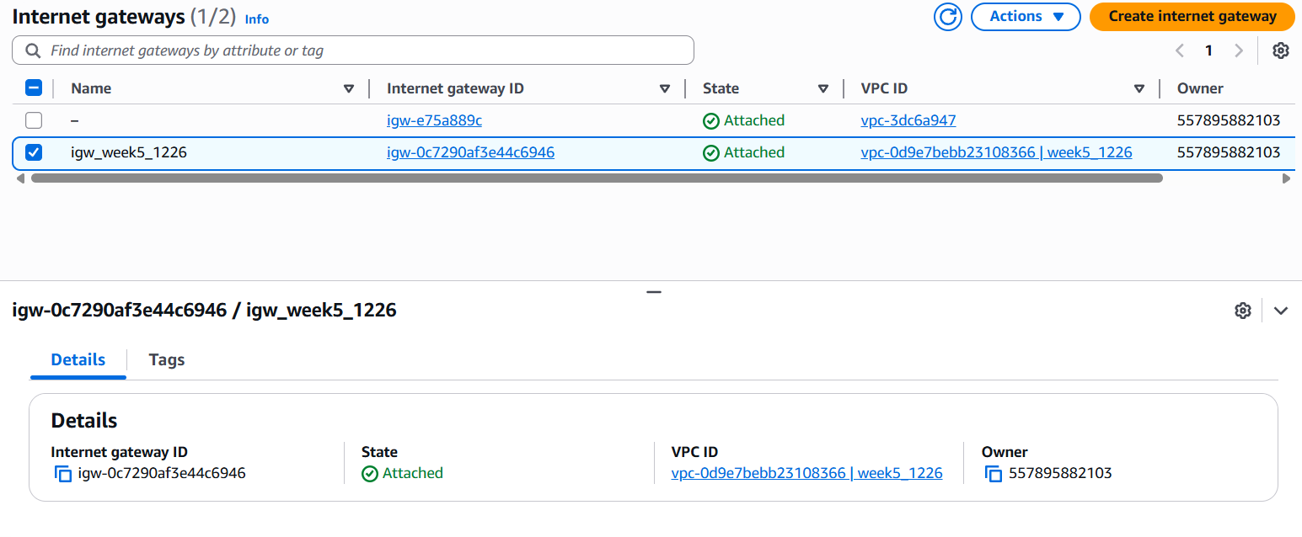

🔹 Step 4: Create Route Tables
You need separate route tables for public and private subnets.

Public Route Table
- Go to Route Tables → Create route table
- Select VPC
- Add route:
  - Destination: 0.0.0.0/0
  - Target: Internet Gateway
- Associate with public subnet
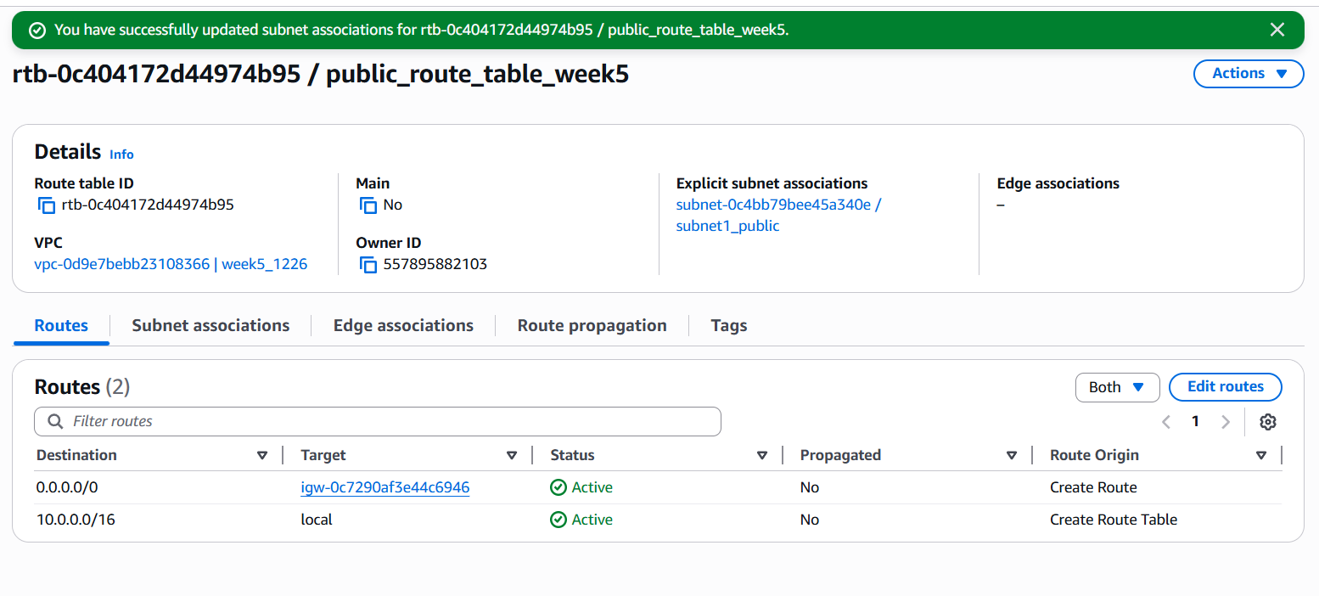

Private Route Table
- Keep default local route only (no IGW)
- Associate with private subnet
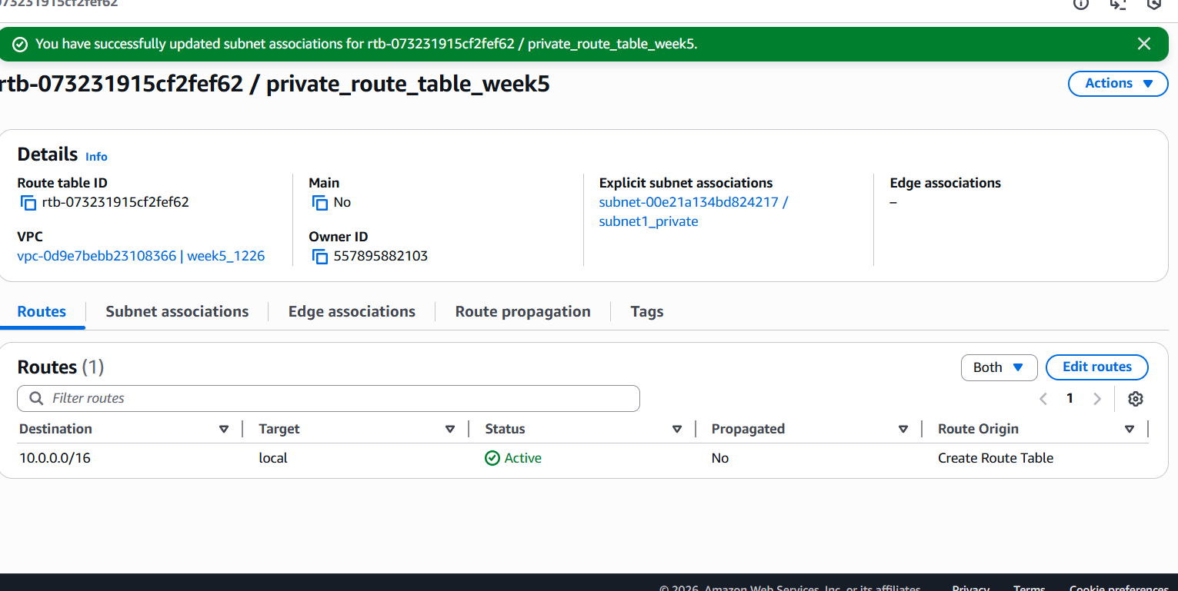

🔹 Step 5: Enable Auto-Assign Public IP (Public Subnet)
- Select Public Subnet
- Go to Edit subnet settings
- Enable Auto-assign public IPv4 address
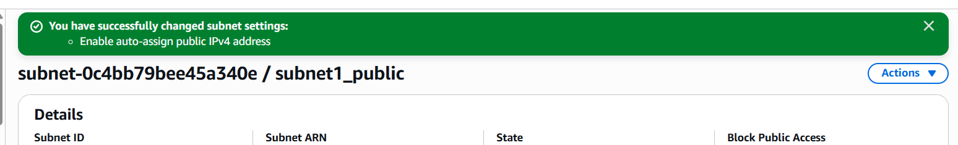

🔹 Step 6: Configure Security Groups
- Create a Security Group
- Add inbound rules:
  - HTTP (80) / HTTPS (443)
  - SSH (22) from trusted IP
- Attach to EC2 instances
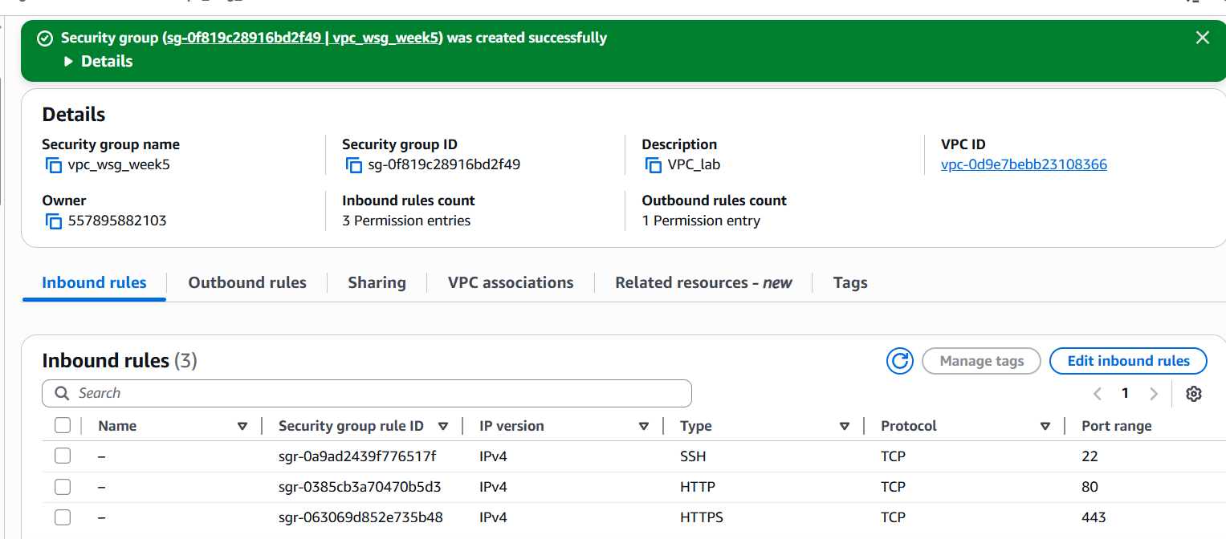

🔹 Step 7: Launch EC2 Instances
- Public EC2 → Public subnet
- Private EC2 → Private subnet
Attach correct security groups.
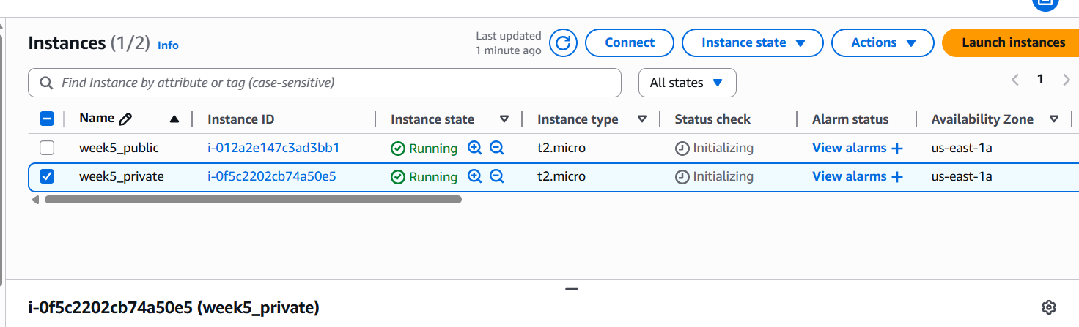

🔹 Step 8: Test the Setup
- Public EC2 → Internet access ✔
- Private EC2 → Internet via NAT ✔
- Private EC2 → No direct inbound access ✔

Scenario Based Questions:

- You have a web application where users access a website, but the database should not be exposed to the internet. How would you design the VPC? Which resources go into public and private subnets?
Ans: Public subnet: ALB, Bastion Host, NAT Gateway. Private subnet: App servers, RDS. DB stays private with no public IP or IGW route.
- An EC2 instance in a public subnet cannot access the internet. What VPC components would you check and why?
Ans: Check: Internet Gateway attached, route table (0.0.0.0/0 → IGW), public IP assigned, security groups, NACLs.
- Your application server needs to connect to an RDS database securely. How would you configure security groups and subnets?
Ans: RDS in private subnet; App server SG allows outbound DB port; RDS SG allows inbound only from App SG (not IP).
- You are asked to design a VPC for 500 servers today, but it should scale to 2,000 servers in the future. How would you choose the CIDR block?
Ans: Use larger CIDR like /20 or /19 (e.g., 10.0.0.0/16 overall VPC) to support future scaling without re-architecting.
- A company wants secure connectivity between its on-premises data center and AWS VPC.
Which AWS services would you choose and why (VPN vs Direct Connect)?
Ans: Use Site-to-Site VPN for quick/low cost setup; use Direct Connect for dedicated, high bandwidth, low latency, enterprise-grade connectivity.
- You need to connect two VPCs, but both use the same CIDR range. How would you solve this problem?
Ans: Use VPC peering with CIDR renumbering, or better: Transit Gateway + NAT/PrivateLink; overlapping CIDRs cannot be peered directly.
- Multiple microservices running in different subnets need to communicate securely. How would you design routing and security groups?
Ans: Separate subnets per service tier; use security groups referencing other SGs (not IPs); restrict routing only where required.
- Design a VPC for a 3-tier application (Web, App, DB) with high security and scalability. Explain subnets, route tables, gateways, and security groups.
Ans: Public subnet: ALB + NAT.
Private subnets (multi-AZ): App + DB.
Route tables: Public → IGW; Private → NAT.
Security groups: Web → App → DB strictly layered.
- You suspect unusual traffic inside your VPC. How would you monitor and analyze network traffic?
Ans: Enable VPC Flow Logs, CloudWatch Logs, CloudTrail; optionally use GuardDuty for threat detection.
- Why can’t a private subnet have an Internet Gateway directly attached?
Ans: Because IGW works only with routes; private subnets intentionally have no 0.0.0.0/0 route to IGW to prevent exposure.
- What happens if route tables are misconfigured in a VPC?
Ans: Traffic won’t reach intended destination; instances lose internet, internal, or cross-subnet connectivity.
- What happens if a route table has no local route?
Ans: VPC routing breaks internally; instances cannot communicate within the VPC (local route is mandatory and auto-created).
- An EC2 instance allows traffic on port 80 in the security group, but traffic is still blocked.
What could be the reason?
Ans: Could be NACL blocking, instance firewall (iptables), no public IP, wrong route table, or ALB misconfiguration.
- You need to create a VPC that will host 1,000+ EC2 instances across multiple AZs.
How do you decide the CIDR block?
Ans: Choose large CIDR like /16 (65,536 IPs) and divide into multiple /20 or /21 subnets per AZ for scaling.
- Only a company’s corporate IP should be able to SSH into EC2 instances. How would you implement this securely in AWS VPC?
Ans: Security group inbound rule: allow SSH (22) only from company’s public IP (x.x.x.x/32); disable 0.0.0.0/0 access.
- An EC2 instance can send traffic out but cannot receive responses. Which VPC component might be misconfigured and why?
Ans: Likely NACL issue (stateless — inbound rule missing) or asymmetric routing causing return traffic to be blocked.

